**Project Title**

**Sales Automobile Using Salesforce CRM**

**Team leader NM ID:**

EC460A3678E421F998E4419067577C24

**Team Members NM ID:**

62D6EE19938A19DACB441209914FCE83

E3A7460FDDE53F7970F431E0375DD73A

700222D90D9ABDB87A443EB5697CF8DD

9D1D14CE4CB1BAE8C324D51507470DD6

## 1. Project Overview

To streamline and enhance the sales process for an automobile dealership using Salesforce CRM, improving customer engagement, sales efficiency, and overall customer satisfaction.

## 2. Objectives

**Business Goals:**

**1. Increase Sales Revenue:**

* Utilize Salesforce CRM to identify high-potential leads and focus efforts on closing deals.
* Improve sales pipeline visibility to ensure efficient resource allocation.

**2. Enhance Customer Experience:**

* Provide personalized communication and proactive service.
* Increase customer satisfaction and loyalty through tailored interactions.
* Streamline sales, marketing, and service processes.

**Specific Outcomes:**

### 1. Higher Conversion Rates:

### Increase the percentage of leads converted to opportunities and closed deals.

### 2. Shortened Sales Cycle:

### Reduce the time taken from lead acquisition to deal closure.

### 3. Salesforce Mobile App

## 1. Real-Time Access: Access your Salesforce data anytime, anywhere. View dashboards, reports, and key metrics on the go.

## 2. Collaboration Tools: Use Chatter to communicate with colleagues, share files, and collaborate on projects

## 4. Detailed Steps to Solution Design

**Requirements Gathering**

1. **Stakeholder Meetings**: Conduct workshops and meetings with key stakeholders (sales, marketing, service teams, and management) to gather requirements.
2. **Business Processes**: Document current business processes and identify pain points and opportunities for improvement.
3. **Goals and KPIs**: Define the business goals, key performance indicators (KPIs), and success criteria for the CRM implementation.

## 5. Testing and Validation

**Unit Testing:**

Apex Classes and Triggers: Write unit tests for all Apex classes and triggers to ensure they function as expected. Use the @isTest annotation in Apex.

Test Data: Create test data within your unit tests to validate different scenarios.

Code Coverage: Aim for at least 75% code coverage, as required by Salesforce.

.

## 6.Key Scenarios Addressed by Salesforce in the Implementation Project

**Lead Management**

* **Scenario**: Capturing leads from multiple sources such as the dealership website, social media, and showroom visits.
* **Solution**: Salesforce automates lead capture and assigns leads to sales reps based on predefined criteria, ensuring timely follow-up and increased conversion rates

**LWC COMPONENT:**

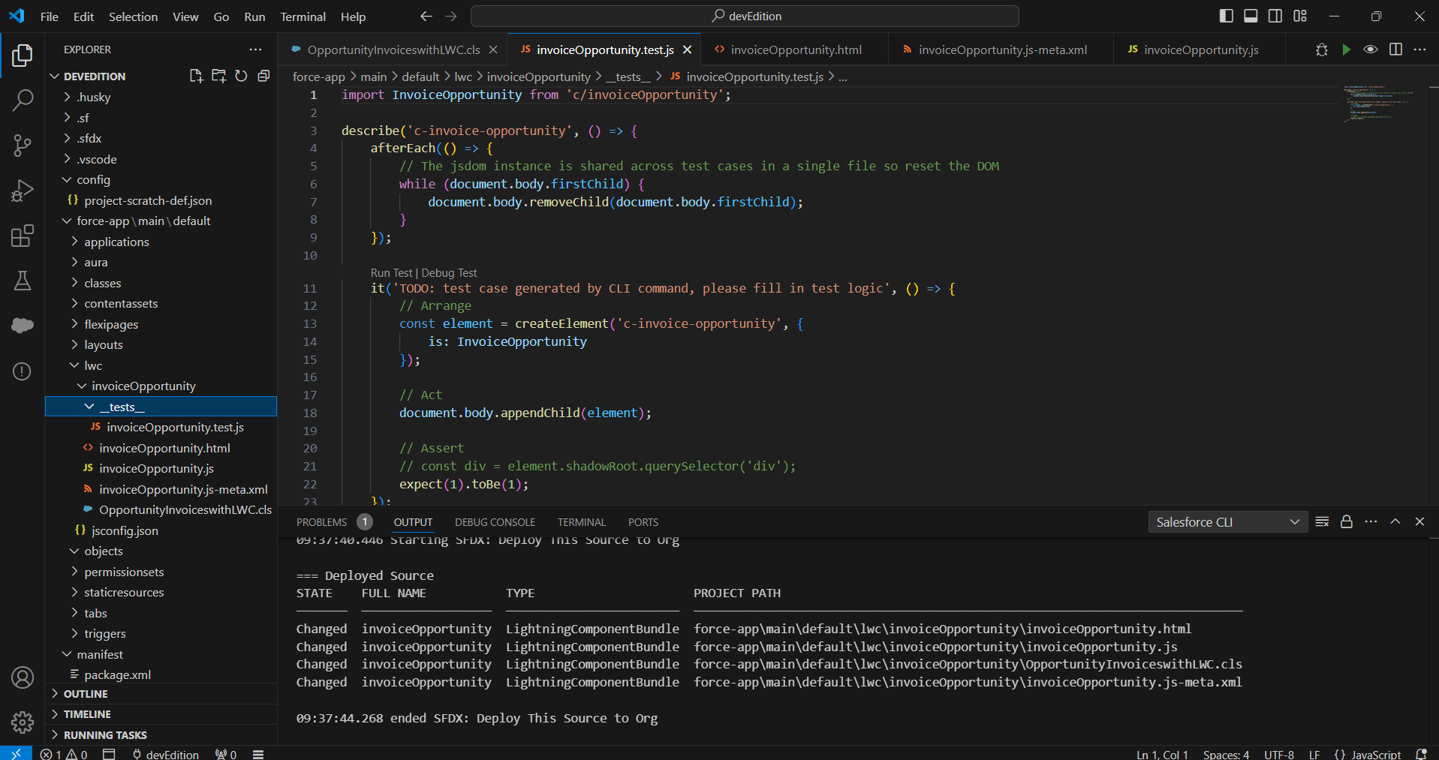

DASHBOARD

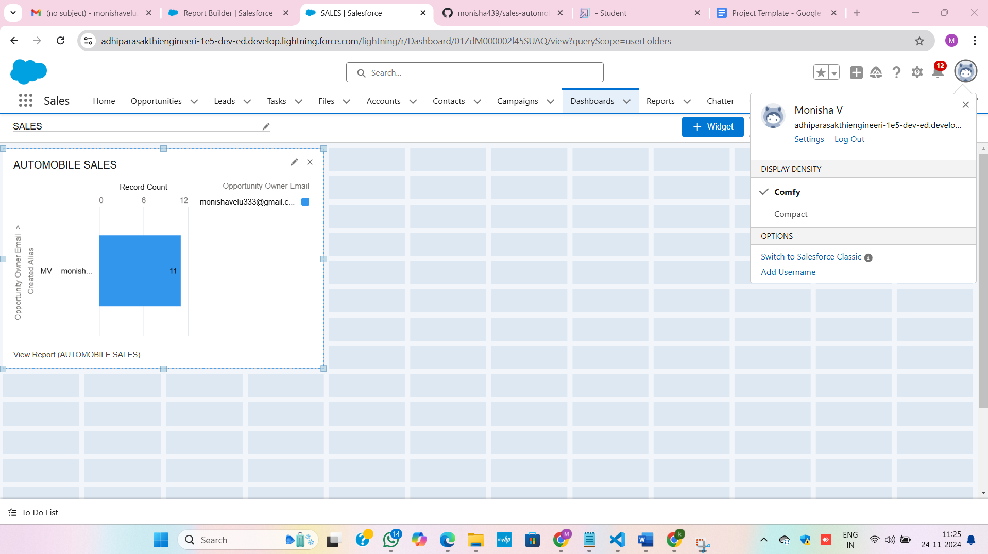

**7.Conclusion :**

The successful Implementing Salesforce CRM for the automobile industry is a strategic move that can significantly enhance sales processes, customer engagement, and operational efficiency. By leveraging Salesforce's robust features, dealerships can streamline their lead management, optimize their sales pipeline, provide personalized customer communication, and gain valuable insights through data analytics.